

**FIRST TERMINAL EXAMINATION – SEPTEMBER2019**

**MATHEMATICS**

**Class: VII Max Marks: 80**

**Date: 26.09.19 Time:3 hours**

**I. Fill in the blanks: (6 × 1= 6)**

1) (– 5) x (–6) x (– 7) = ________

2) (–8) + (–8) + (–8) = _____ x (–8)

3) A regular polygon has as many lines of symmetry as the number of ___.

4) Fractions having numerator less than the denominator are called ________ fractions.

5) A ________ has infinite lines of symmetry.

6) The decimal form of 3000+50+ is _______.

**II. Answer the following: (6 ×2=12)**

7) Find the sum of -49 and -36.

8) Convert as indicated:

a) 3 into an improper fraction.

b) into a mixed fraction.

9) Convert the following into their simplest form:

a) 0.24 (b) 

10) Evaluate (0.7)

11) Divide :

a) 675.5 by 100

b) 0.9 by 10

12) Draw the line of symmetry for the following:



**III. Answer the following: (10x3=30)**

13) Evaluate:

[250 x (-32)] [(-125) x (-16)]

14) Find the sum:

8+ 10

15) Simplify:

xx

16) What should be added to 12 to get 15?

(OR)

17) The product of two numbers is 1 .If one of the numbers is 5, find the other.

18) Add 13.64; 9.281 and 35

19) Arrange in ascending order: 0.98 ; 9.8; 8.9; 9.08; 8.3; 0.098

20) Subtract 10.581 from 285.4

21) If 389x17 = 6613, find

a) 3.89x17

b) 38.9x1.7

c) 0.389x0.17

22) Find the quotient when 16.578 is divided by 5.4

(OR)

23) Divide 290.14 by 89

24) Find the mean of the following marks of a student 77,68,52,50,73,72

(OR)

25) Find the mean of all the factors of 30.

**IV Answer the following (8x4=32)**

26) Find the median of the following data:

a) 12,14,15,14,15,17,18,19,17,17,20,21,22,19,19

b) 35,36,27,32,23,39,40,55,28,32,46,45

27) The size of 10 shirts (in cm) are as follows:

90,95,100,90,95,90,100,95,90,105

Prepare a frequency distribution table and also find the mode of the data.

28) Verify (a + b) + c= a + (b + c),if a = 32,b =–37 and c= –44

29) A book has 2150 pages. Dhivya read  of the book. How many pages has she read? How many pages are not read by her?

30) Construct ∆ABC, given that AB=4.5cm,BC=5.8cm and AC=5.2cm.Write down the steps of construction.

(OR)

31) Draw a line PQ .Construct a line parallel to PQ at a distance of 4.6cm from it.

32) The cost of a book is Rs.29.75.Find the cost of 2 dozens of books.

33) The following table shows the favorite sports of 300 students of a school.

|  |  |  |  |  |  |  |
| --- | --- | --- | --- | --- | --- | --- |
| **Sports** | Cricket | Football | Hockey | Badminton | Swimming | Tennis |
| **No. of Students** | 80 | 40 | 20 | 30 | 45 | 75 |

Represent the above data using a bar graph.

34) Read the following graph and answer the questions that follow

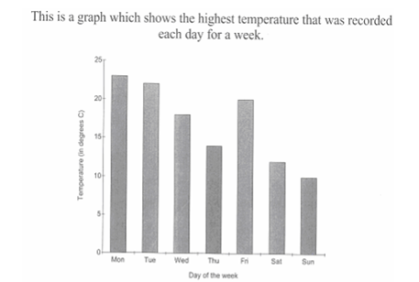

(1) Which day had the highest temperature?

(2) What was the temperature on Saturday?

(3) How much higher was the temperature on Saturday compared to that on Monday?

(4) Which day recorded the least temperature and how much?